Data Input Handling

🧾 What Is Data Input Handling?
# Source: AI Source: Provided by: [Data Path: Persons Table -> ID Column: 1, Name_En Column: Motasem Essam] -> From: [ChatGPT] on [2/12/2026]
Data input handling is the process of receiving, validating, and preparing user input before it is processed or stored.
👉 It ensures the data is correct, safe, and usable.

✅ Simple Definition:
# Source: AI Source: Provided by: [Data Path: Persons Table -> ID Column: 1, Name_En Column: Motasem Essam] -> From: [ChatGPT] on [2/12/2026]
Data input handling is how a system collects and checks user input before using it.

🧠 Real-Life Analogy:
# Source: AI Source: Provided by: [Data Path: Persons Table -> ID Column: 1, Name_En Column: Motasem Essam] -> From: [ChatGPT] on [2/12/2026]
Think of it like a security checkpoint at an airport ✈️:
● You provide your information (input)
● Security checks it (validation)
● If valid → you pass
● If invalid → you are rejected

🔁 How Data Input Handling Works
# Source: AI Source: Provided by: [Data Path: Persons Table -> ID Column: 1, Name_En Column: Motasem Essam] -> From: [ChatGPT] on [2/12/2026]
- 👤 User enters data (form, API, etc.)
- 📥 Server receives the input
- 🔍 Validate the data (correct format, required fields)
- 🧹 Sanitize the data (remove harmful content)
- ✅ Process or store the data

📥 Sources of Input
# Source: AI Source: Provided by: [Data Path: Persons Table -> ID Column: 1, Name_En Column: Motasem Essam] -> From: [ChatGPT] on [2/12/2026]
● HTML forms
● API requests (JSON)
● URL parameters (GET)
● Cookies
● Files (uploads)

🔍 Validation vs Sanitization

🔹 Validation (Check correctness)
# Source: AI Source: Provided by: [Data Path: Persons Table -> ID Column: 1, Name_En Column: Motasem Essam] -> From: [ChatGPT] on [2/12/2026]
● Is email valid?
● Is password long enough?
● Is field required?

🔹 Sanitization (Clean data)
# Source: AI Source: Provided by: [Data Path: Persons Table -> ID Column: 1, Name_En Column: Motasem Essam] -> From: [ChatGPT] on [2/12/2026]
● Remove scripts
● Escape special characters
● Prevent attacks

⚠️ Why It’s Important
# Source: AI Source: Provided by: [Data Path: Persons Table -> ID Column: 1, Name_En Column: Motasem Essam] -> From: [ChatGPT] on [2/12/2026]
Without input handling:
❌ Invalid data enters system
❌ Security vulnerabilities
❌ Application crashes
👉 It protects your system

🛡️ Common Attacks Prevented
# Source: AI Source: Provided by: [Data Path: Persons Table -> ID Column: 1, Name_En Column: Motasem Essam] -> From: [ChatGPT] on [2/12/2026]
● SQL Injection
● Cross-Site Scripting (XSS)
● Malicious input

💻 Simple PHP Example
# Source: AI Source: Provided by: [Data Path: Persons Table -> ID Column: 1, Name_En Column: Motasem Essam] -> From: [ChatGPT] on [2/12/2026]
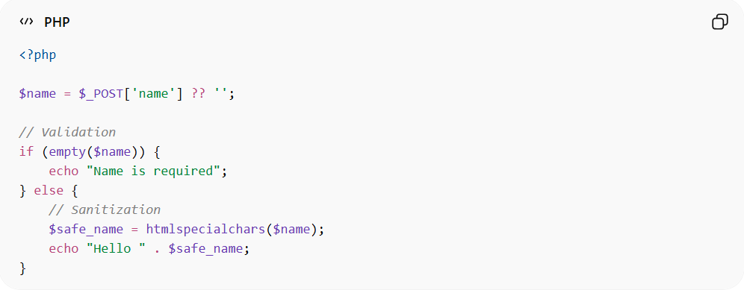
<?php

$name = $_POST['name'] ?? '';

// Validation
if (empty($name)) {
echo "Name is required";
} else {
// Sanitization
$safe_name = htmlspecialchars($name);
echo "Hello " . $safe_name;
}
● Checks if input exists
● Cleans input using htmlspecialchars()
● Prevents XSS

📦 Example (JSON Input)
# Source: AI Source: Provided by: [Data Path: Persons Table -> ID Column: 1, Name_En Column: Motasem Essam] -> From: [ChatGPT] on [2/12/2026]
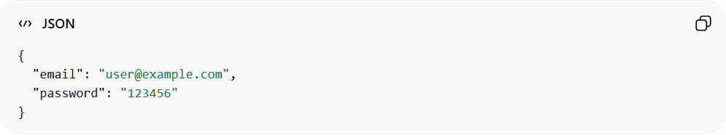
{
"email": "user@example.com",
"password": "123456"
}
👉 Server must validate:
- email format
- password strength

🔗 Relation to Other Topics
# Source: AI Source: Provided by: [Data Path: Persons Table -> ID Column: 1, Name_En Column: Motasem Essam] -> From: [ChatGPT] on [2/12/2026]
● HTTP Requests → carry input data
● Data Formats → structure of input (JSON, form-data)
● APIs → receive and process input
● Headers → may include metadata about input

⚙️ Best Practices
# Source: AI Source: Provided by: [Data Path: Persons Table -> ID Column: 1, Name_En Column: Motasem Essam] -> From: [ChatGPT] on [2/12/2026]
✅ Always validate input
✅ Sanitize before storing/displaying
✅ Use prepared statements (DB security)
✅ Never trust user input

🎯 Key Idea
# Source: AI Source: Provided by: [Data Path: Persons Table -> ID Column: 1, Name_En Column: Motasem Essam] -> From: [ChatGPT] on [2/12/2026]
👉 Input handling = validate + sanitize + process
👉 Never trust user input

🎓 Final Mental Model
# Source: AI Source: Provided by: [Data Path: Persons Table -> ID Column: 1, Name_En Column: Motasem Essam] -> From: [ChatGPT] on [2/12/2026]
● Input = user data
● Validation = check it
● Sanitization = clean it
👉 Safe input = secure application 🔥

